**Git and GitHub Basic Commands**

Git is a version control system that lets you manage and keep track of your source code history. GitHub is a cloud-based hosting service that lets you manage Git repositories.

Check git version - To display the version of git present on your machine.

Example:- git --version

[](https://user-images.githubusercontent.com/92079088/196049493-91bab9ff-4e32-4d8c-99db-56285a0c3270.png)

**1. init - To initialize empty Git repository.**

Example:- git init

[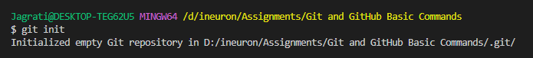](https://user-images.githubusercontent.com/92079088/195949034-36ee4509-427f-4360-89e6-7c31091ee34a.png)

**2. config - To introduce git with username and email id.**

a) For username -

Example:- git config --global user.name "your_username"

[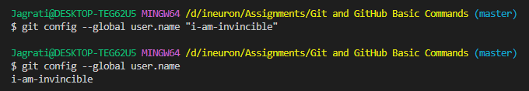](https://user-images.githubusercontent.com/92079088/196049257-e2e7638c-1caf-4ecb-a90b-529c188aa174.png)

b) For email id -

Example:- git config --global user.email "your_email@gmail.com"

[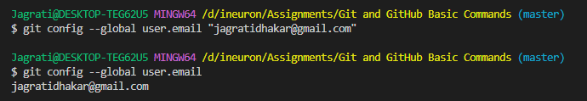](https://user-images.githubusercontent.com/92079088/196049264-5d967b26-45d8-4720-a6a7-b3ea58dfa9c2.png)

**3. status - To display the state of the working directory and the staging area.**

Example:- git status

[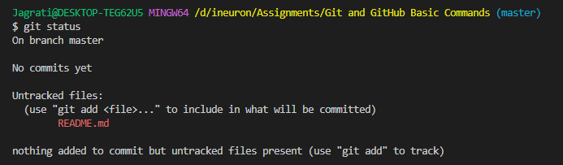](https://user-images.githubusercontent.com/92079088/196049163-b9d266d5-04d2-4105-b0cc-97e634feb1d0.png)

**4. add -**

a) git add "filename" - To add files to the staging area to track the files.

Example:- git add "filename"

[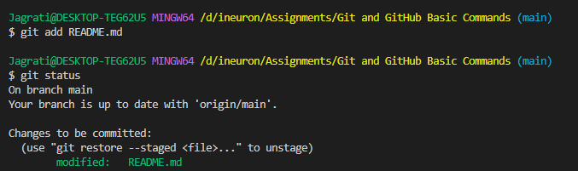](https://user-images.githubusercontent.com/92079088/196049182-456100ca-1c14-4f4b-99eb-d7407f4dd7ad.png)

b) git add . - To add all the files available in the repository.

Example:- git add .

[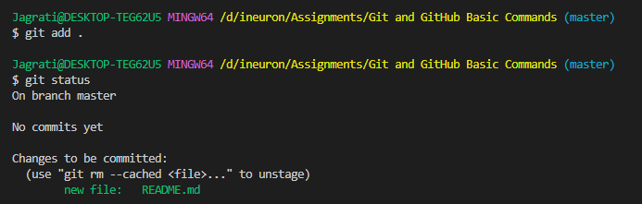](https://user-images.githubusercontent.com/92079088/196049192-66643507-b7e4-4d44-96df-4098e96a13eb.png)

**5. commit - To capture a snapshot of the project's currently staged changes.**

Example:- git commit -m "Message"

[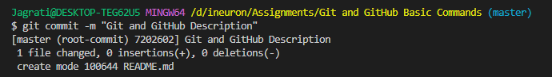](https://user-images.githubusercontent.com/92079088/196049535-65a64874-0a71-4479-b1c8-7374d7100bc0.png)

**6. branch -**

a) check branches - To list all the branches and to check the present branch in the Github repo.

Example:- git branch

[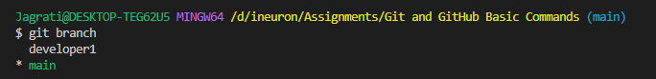](https://user-images.githubusercontent.com/92079088/196051964-cbaf19b4-5529-4522-9291-e6ea89e45eba.png)

Note : If initially your branch is master then change branch name from master to main, so that it can be compactable with github.

Example:- git branch -M main

[git branch name change](https://user-images.githubusercontent.com/92079088/196054674-dc7a2fff-12fd-4a3d-9f89-3dd535f668d4.png)

b) new branch - To create a new branch.

Example:- git branch developer2

[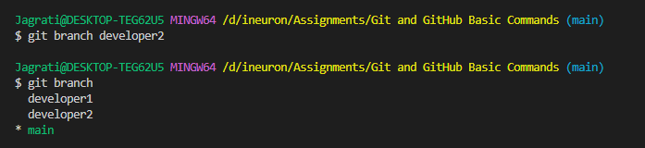](https://user-images.githubusercontent.com/92079088/196054790-138fd5c0-9ea8-4117-8a2a-320e82452a32.png)

c) switch branch - To switch from the new branch and move to the main branch.

Example:- git checkout developer1

[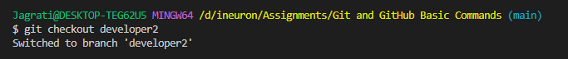](https://user-images.githubusercontent.com/92079088/196054300-180c681d-6b89-4e55-914e-6af1ca5b89fb.png)

d) delete branch - To delete a branch from the git repo.

Example:- git branch -d developer2

[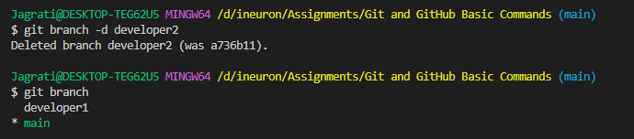](https://user-images.githubusercontent.com/92079088/196054917-b6ecc6c8-ba1f-4a9f-af23-89ce907a878b.png)

**7. remote -**

a) git remote add origin - To link the git repository in which user wants to push their local code. It helps in creating connections with other repositories.

Example:- git remote add origin <git repo url>

[7  a) git remote](https://user-images.githubusercontent.com/92079088/196049554-5bbccd99-7813-4fd5-8305-5d0fe5e0c7ea.png)

b) git remote -v - To list the remote connection user has to other repositories.

Example:- git remote a-v

[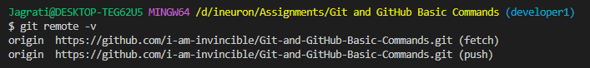](https://user-images.githubusercontent.com/92079088/196049589-d5ab8f2b-1cab-4a34-a16f-17fbdcee9073.png)

**8. push - To push the branch or to push the changes in the branch to the GitHub repo.**

Example:- git push origin main

[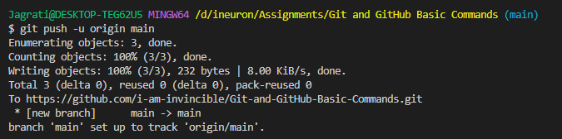](https://user-images.githubusercontent.com/92079088/196049598-d46615b4-800a-4bb8-8bbe-a85557320b7f.png)

**9. log - To display all the commits in a repository's history.**

Example:- git log

[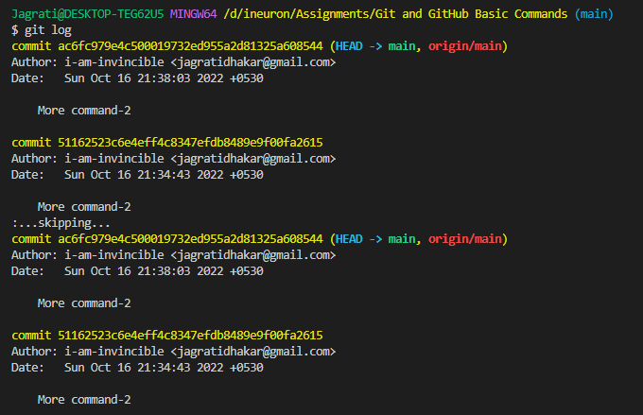](https://user-images.githubusercontent.com/92079088/196049618-a674923c-9716-4526-b4a3-6038378b818a.png)

**10. merge - To merge the current branch into the specified branch (main).**

Example:- git merge branch_name

[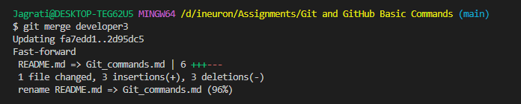](https://user-images.githubusercontent.com/92079088/196057637-0528baa1-2b67-479c-98c4-09c03a16445f.png)

**11. restore - To unstage or even discard uncommitted local changes.**

Example:- git restore <filename>

[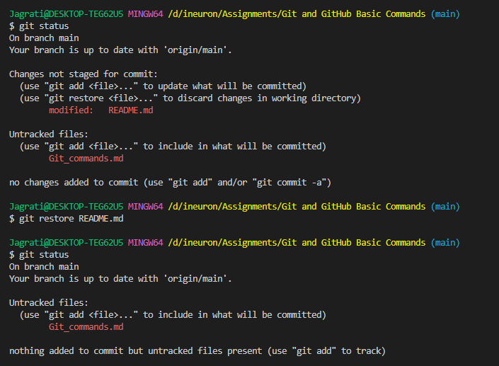](https://user-images.githubusercontent.com/92079088/196057630-d83c728e-6da0-4cb1-b0e9-f04823056fc2.png)

**12. reset - To undo the recent changes that are to be committed.**

Example:- git restore <filename>

[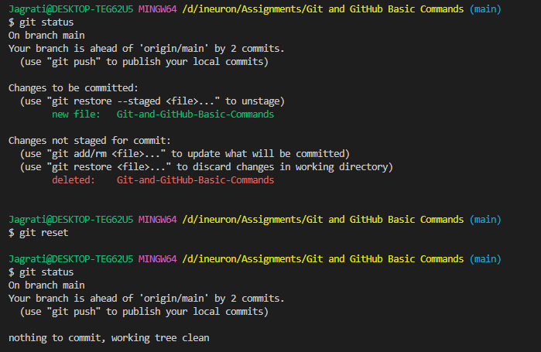](https://user-images.githubusercontent.com/92079088/196054423-09c9c438-5428-41ec-89c4-907177bf57d4.png)

**13. stash - To take your uncommitted changes (both staged and unstaged), saves them away for later use, and then reverts them from your working copy**

Example:- git stash

[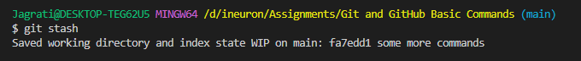](https://user-images.githubusercontent.com/92079088/196057618-6ba2e748-fe63-4750-a791-3a735dd10c73.png)

**14. clone - To point to an existing repo and make a clone or copy of that repo at in a new directory, at another location.**

Example:- git clone <git repo url>

[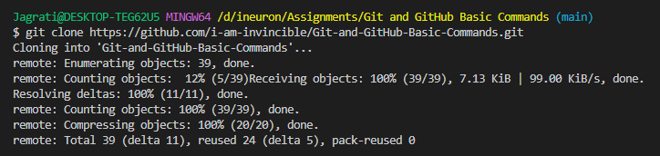](https://user-images.githubusercontent.com/92079088/196054406-a68ce8e5-bd28-44aa-8db4-db5c0f69069f.png)

**15. pull - To pull the new changes from git repository to local machine.**

Example:- git pull

[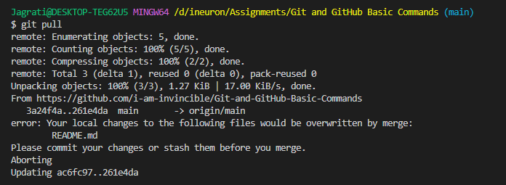](https://user-images.githubusercontent.com/92079088/196054380-5c3c6607-0e3b-47d2-b6ab-1a28ae536205.png)

**THANK YOU !**